Intake Piece

Reverse intake

Speaker Prep Podium

Speaker Prep Stage

Speaker shot from speaker

Overhead Speaker Prep

Up:

Down:

Left:

Right: Prep for amp shot

Pit Shot

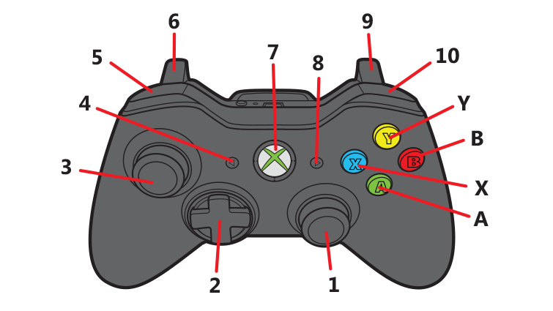

Reset Pose

Shoot